Ideation Phase

Brainstorm & Idea Prioritization Template

Date | 1 November 2025
Team ID | NM2025TMID09066
Project Name | Streamlining Ticket Assignment for Efficient Support Operations
Maximum Marks | 4 Marks

Step-1: Team Gathering, Collaboration and Select the Problem Statement
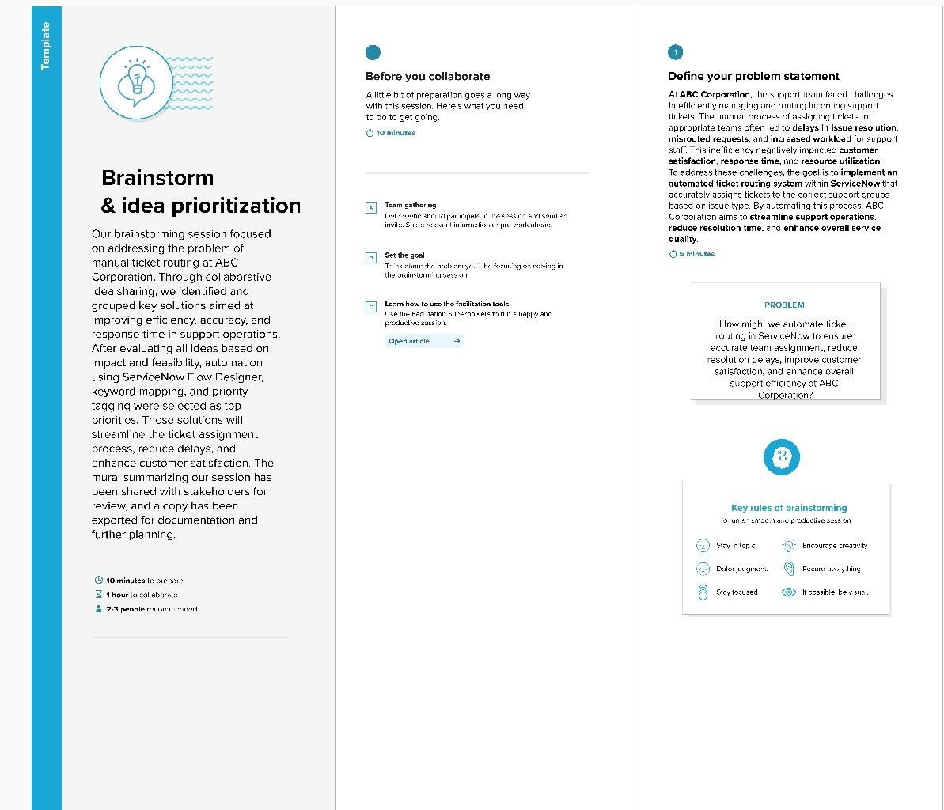

Step-2: Brainstorm, Idea Listing and Grouping
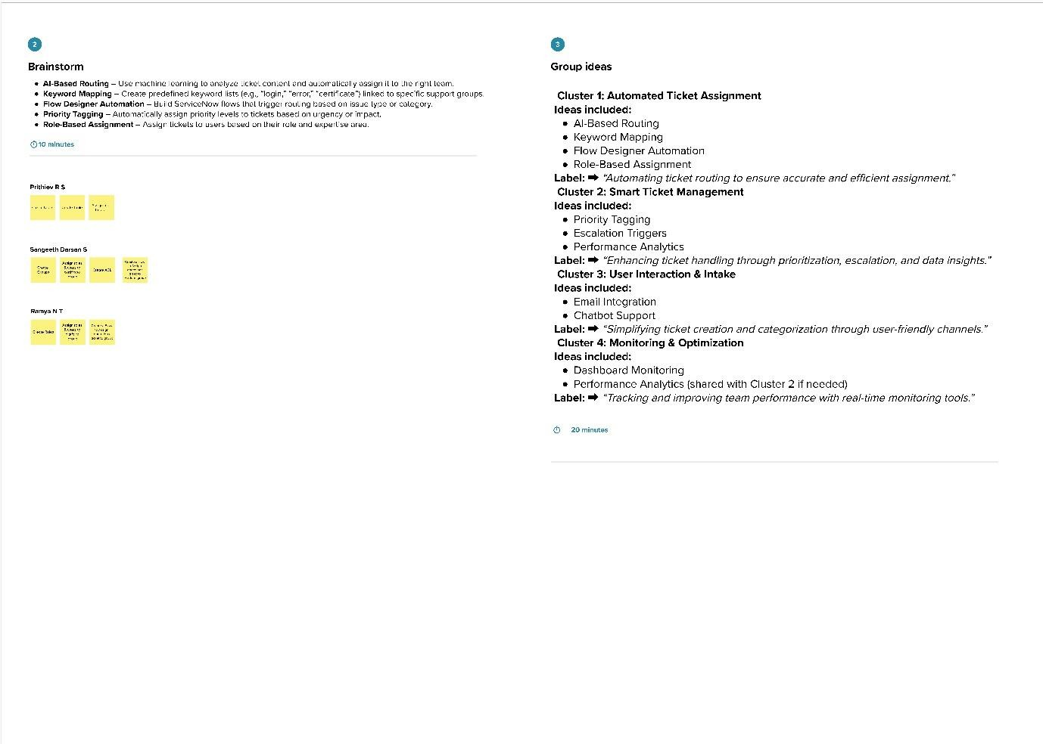
Step-3: Idea Prioritization

